**Detection of Anomaly in SAR Images**

**A) Problem Statement:**

**Definition:**

The stated problem deals with the issues associated with the Synthetic Aperture Radar (SAR) imagery. SAR images, besides of having great applications like performing acquisition of visual information in typical constraints viz. weather and illumination, SAR images are encompassed with disturbing noises and other anomalies which deviate from standard or expected results. Theses anomalies must be detected to minimize the discrepancies.

**Challenges:**

Previously, various algorithms have been proposed by the researchers for anomaly detection in SAR imagery, terrain classification, terrain segmentation etc. but they are engrossed with two major drawbacks which come up as the main challenges:

1. **Higher computational** **complexity** while processing the large-scaled images. Segmentation approaches like graph partitioning pertains high processing time.
2. **Low accuracy rate** of previously proposed methods on detection of the target source.

**Scope:**

Synthetic Aperture Radar, simply abbreviated as SAR images which are used for microwave imaging of things, typically the terrain.  Synthetic Aperture Radar (SAR) leverages the long-distance signals propagation characteristics of radar and capabilities of modern digital electronics of processing complex information to provide high resolution imagery.  SAR remains unaffected by cloud cover or other things that can obstruct visual imaging which also helps in taking images in zero-light conditions. SAR is essentially measuring the normalized radar cross section (RCS) of the ground or whatever we are pointing.

Anomaly detection is applied to detect and sign the ground pixels which are different from the clutter background based on the pattern recognition and the statistical methods. Keeping in view the same, anomaly detection in SAR images with high accuracy rate and low processing time can be proved extremely applicable and serviceable.

The proposed project will perform efficiently and effectively in extracting information from even low- resolution images.

**B)** **Background**

Many researchers have deployed various algorithms and proposed works based on SAR imagery. Recent approaches include the statistically based automatic detection of marine oil slacks, detecting fluid paths in geothermal fields, Temporal Change Detection in SAR ImagesUsing Log Cumulants and Stacked Auto-encode, Flood extent mapping from time-series SAR images based on texture analysis and data fusion, Evaluation of Multi-Frequency SAR Images for Tropical Land Cover Mapping, Terrain Classification based on Spatial Multi-attribute Graph using Polarimetric SAR Data, non-stationary speckle reduction in high resolution SAR images, urban impervious surface classification from SAR images. Hence, the previous works include quite old and obsolete tools and techniques which increase the computing time while lowering the accuracy rate.

**C) Methodology**

The architecture diagram for Detection of Anomaly in SAR images is shown in Figure 1.

**Image Preprocessing**

**Input Output**

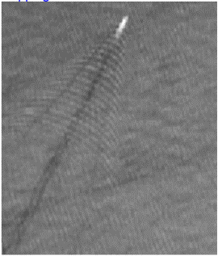 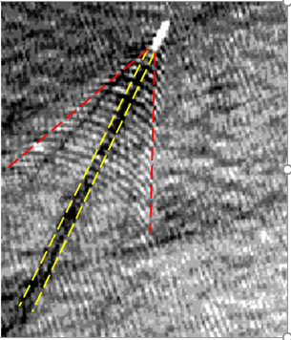

Image Transformation

Anomaly Detection Model

Development

Information Extraction

Anomaly Detection Model

SAR Imagery Turbulent wake(Ship)

SAR Database

Figure 1: Architecture Diagram for Detection of Anomaly in SAR images

Above architecture diagram incorporates 4 steps which show the how this project will be processed which are collection of SAR images from various satellite sources, images transformation using available data augmentation techniques then information or feature extraction of processed images and then train and develop the CNN based anomaly detection model using pretrained models such as VGG16, VGG19 , Mobile Net , ResNet etc.

[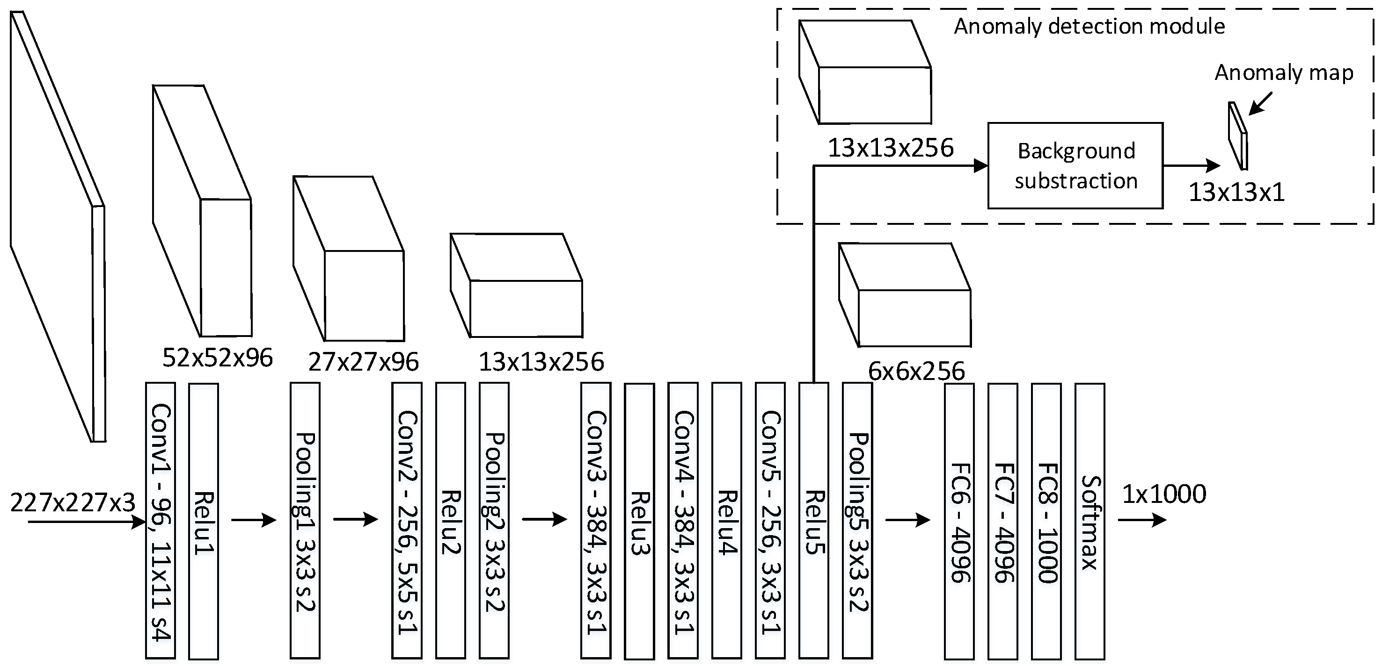](https://www.google.com/url?sa=i&rct=j&q=&esrc=s&source=images&cd=&cad=rja&uact=8&ved=2ahUKEwjL5OOfnOXaAhUdT48KHZRLCLcQjRx6BAgBEAU&url=http://www.mdpi.com/1424-8220/16/11/1904/htm&psig=AOvVaw3v_mva4Q9vvW8td1J3_1hT&ust=1525288367513305)

Figure 2: Detection of Anomaly in SAR images using pre-trained VGG16 CNN

The anomalies will be removed by using contemporary techniques which comprises machine learning and image processing algorithms. This will reduce the computational cost of the proposed approach and increase the accuracy rate.

**D) Experimental Design**

**Dataset:**

The solution depends on the datasets obtained from data recorded by geostationary satellites and Indian Weather Satellites.

**Evaluation measures:**

This project deals with the detection of anomalies such as aircrafts, unmanned Aerial vehicle (UAV) or drones in SAR images. These anomalies can be related to threats at airports, under water vehicles such as submarines etc. For further evaluation SAR images of objects can be taken at different angles at different time. Afterwards, evaluation measures such as size, distance, angle, orientation of anomaly or outlier can be detected with respect to the object and Mean Average Precision(MAP) and accuracy will be computed by comparing the detected anomalies in SAR images and ground truth images of satellites.

**Software and Hardware requirements:**

The following are likely used technologies for the proposed work to solve the problem:

1. OpenCV library which provides real-time computer vision and machine learning software library.
2. Python that is an efficient and debugging programming language.